FOR IMMEDIATE RELEASE


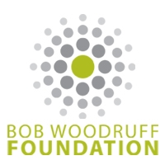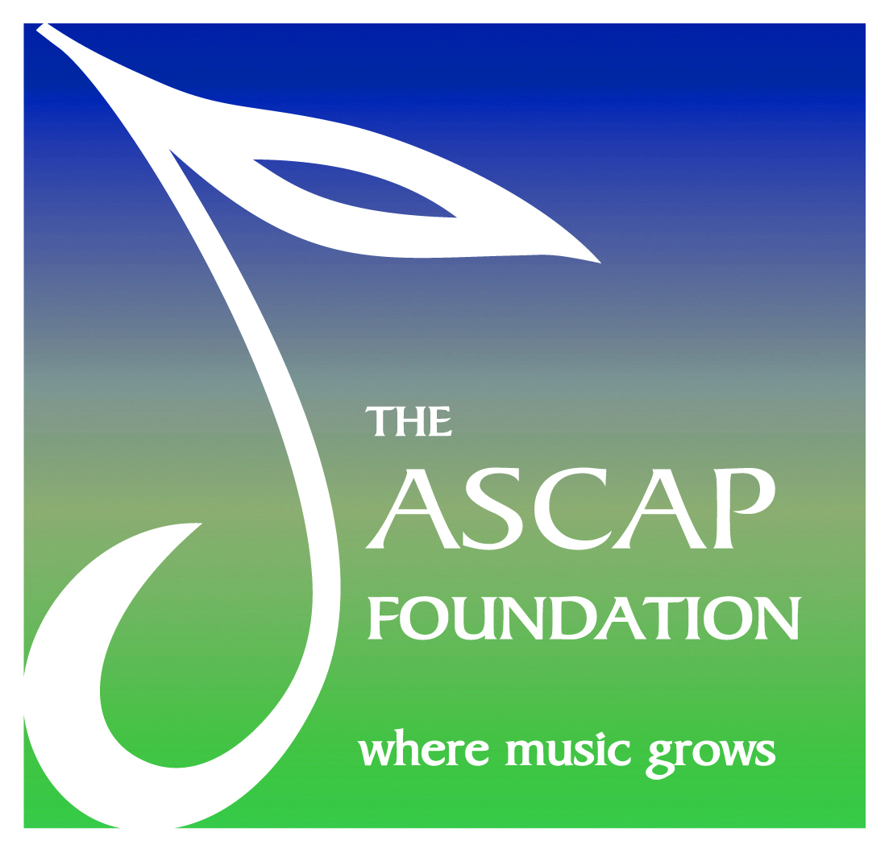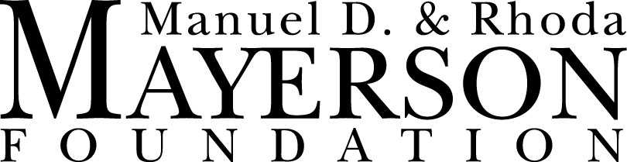

Songwriting retreat for veterans expands reach, impact
Bob Woodruff Foundation, ASCAP Foundation, Lockheed Martin and more
help SongwritingWith:Soldiers broaden reach and build community

BELTON, TEXAS – Twelve active duty military service members and their guests will take part in a unique opportunity to share their stories with professional songwriters during the SongwritingWith:Soldiers retreat at the Cedarbrake Renewal Center in Belton, Texas, April 26-28, 2013. The Bob Woodruff Foundation, The ASCAP Foundation, Lockheed Martin, Veterans United Foundation, The Mayerson Foundation and the Charleston Center for Photography have joined SongwritingWith:Soldiers to provide stress relief and deeper connections for returning U.S. service members of Iraq and Afghanistan suffering from Post Traumatic Stress (PTS) and traumatic brain injuries.

Program creator and Austin-based songwriter Darden Smith, along with professional songwriters Jay Clementi, Darrell Scott and Gary Nicholson, will be paired with military members in a retreat setting to write songs based on their combat experience and its effect on them since returning home. The private retreat center allows for an intimate event that fosters connections, and the schedule includes time for personal relaxation, creativity coaching and conversation. Participants stay connected post retreat via conference calls, interactive forums and volunteering at future events. All participants will be considered co-writers of their songs and will be registered as such with ASCAP. This will ensure that, if applicable, they will share in any royalties stemming from the public performance of their work. The songs written during the retreat will be recorded on-site and distributed to the participants.

“My passion for songwriting has often landed me in unexpected terrain,” says Smith. “Songwriting with U.S. soldiers who have returned from combat is certainly one of the most unusual – and rewarding – career turns I never ever imagined. Now, we have several past retreat participants who've asked to help out, including some who were reluctant to attend last time. I can't think of a better endorsement.”

In recent years, Smith established Be An Artist, Inc., a nonprofit organization dedicated to sponsoring projects that bring arts and creativity into educational settings. SongwritingWith:Soldiers emerged out of this program and continues to expand its reach.

“As the number of military suicides rises -- up to 22 per day -- we are more determined than ever to reach more service men and women with our program,” says SongwritingWith:Soldiers Executive Director Mary Judd. “One of our goals is to develop materials to help replicate the program on a broad scale. We have seen the healing effects. More service men and women need this opportunity. More songwriters need this opportunity, too."
Additional veterans in attendance will include award-winning combat photographers Andy Dunaway and Stacy Pearsall (recently honored as a White House Champion of Change), and combat veteran and videographer James Monk with Mercy Lamp Productions.

“Songwriting With: Soldiers is a creative means to cathartic healing,” said Bob Woodruff Foundation Executive Director Anne Marie Dougherty. “Our goal at the Bob Woodruff Foundation is to find programs that leave service members feeling both empowered and fulfilled, and we firmly believe that sharing their unique stories at this innovative retreat will do just that.”

ASCAP Foundation President Paul Williams – an Oscar, Grammy and Golden Globe Award-winning songwriter and Songwriters Hall of Fame inductee – commented on the program and upcoming retreat: "Music has always been a great healer and the creative act of writing offers a unique and powerful outlet for the painful memories and hidden scars of warfare. There is no finer use of our talents than offering this natural therapy to the young servicemen and women who have given so much. Darden Smith, Radney Foster and Jay Clementi and the Songwriting With: Soldiers team deserve our thanks and support. Without doubt, some fine songs will result from the retreat and, more importantly, the chance to show our troops how much we care."

“We are always on the lookout for organizations that understand it isn’t how many you serve, it is how deeply you affect them, “ says Miranda Chapin of Veterans United Foundation. “From everything we see, SongwritingWith:Soldiers has a deep impact on the participants. We are excited to help them reach more.”

“SongwritingWith:Soldiers helps re-humanize all of us who have been injured by the de-humanizing effects of war and conflict,” says Neal Mayerson, Chairman of the Mayerson Foundation . The medium of music through which this organization works readily engages the spirit and soul of both the participants and those who listen to the songs they produce.

Additional retreats are being planned for 2013.

Listen to songs from the last retreat here:
www.songwritingwithsoldiers.com/music

For more information about the SongwritingWith:Soldiers program and retreats, visit www.songwritingwithsoldiers.com.

About SongwritingWith:Soldiers
SongwritingWith:Soldiers is a program created by Darden Smith that pairs professional songwriters with soldiers and veterans to relieve stress and build community by writing songs based on stories of combat and returning home. This unique process provides a lasting document of the veterans’ story, in song form, that they can have and share. SongwritingWith:Soldiers is a part of Be An Artist, Inc., a non-profit organization that focuses on songwriting to bring arts and creativity into a variety of educational settings.
Other programs sponsored by Be An Artist, Inc. include The Be An Artist Program, bringing creativity workshops based on songwriting to schools across the U.S. and Europe; SongwritingWith: CovenantHouse, working within a shelter for homeless youth in Newark, N.J. to help the residents tell their stories through song; and SongwritingWith:Africa, working within communities of Botswana and South Africa to help relate the effects of HIV and AIDS.
About the Bob Woodruff Foundation
Helping heroes on the homefront
The Bob Woodruff Foundation is the nonprofit dedicated to ensuring injured service members and their families are thriving long after they return home. A national organization with grassroots reach, the Bob Woodruff Foundation complements the work of the federal government —diligently navigating the maze of more than 40,000 nonprofits providing services to veterans—finds, funds and shapes innovative programs, and holds them accountable for results. To date, we have invested more than $15 million in public education and solutions, reaching more than a million service members, support personnel, veterans and their families. The Bob Woodruff Foundation was co-founded in 2006 by award-winning anchor Bob Woodruff and his family, whose own experiences inspired them to help make sure our nation’s heroes have access to the high level of support and resources they deserve, for as long as they need it. For more information about the Bob Woodruff Foundation, please visit www.bobwoodrufffoundation.org.

About The ASCAP Foundation
Founded in 1975, The ASCAP Foundation is a charitable organization dedicated to supporting American music creators and encouraging their development through music education and talent development programs. Included in these are songwriting workshops, grants, scholarships, awards, recognition and community outreach programs for songwriters, composers and lyricists. The ASCAP Foundation is supported by contributions from ASCAP members and from music lovers throughout the United States. www.ascapfoundation.org

About Lockheed Martin
Headquartered in Bethesda, Md., Lockheed Martin is a global security and aerospace company that employs about 120,000 people worldwide and is principally engaged in the research, design, development, manufacture, integration and sustainment of advanced technology systems, products and services. The corporation's net sales for 2012 were $47.2 billion.
About Charleston Center for Photography
The Charleston Center for Photography is owned by Stacy Pearsall and Andy Dunaway, both award-winning combat photographers, whose works -- and awards - reach far beyond the battlefield. The Center offers classes, printing services, studio rentals, special events and much more. Many of the photos on SWS website, press materials, and gift books were taken by Stacy and Andy. www.ccforp.org

About the Manuel D. and Rhoda Mayerson Foundation –
The Manuel D. and Rhoda Mayerson Foundation (www.mayersonfoundation.org) is dedicated to creating communities that are just, caring and respectful – communities in which marginalized populations are empowered and all people have opportunities to seek their highest aspirations. In making funding decisions, the Directors of the Foundation are responsive to sound strategic planning, organizational stability, leadership, creativity, entrepreneurial visioning, leveraging of resources, collaboration and empowerment of people. Additionally, there is a focus on providing funding to worthy efforts that otherwise struggle to find vital support. In short, the Foundation is interested in projects that figure out how to make an impact and do it broadly with an efficient use of resources. And, it likes to see its funding and involvement serve a catalytic role in turning possibilities into reality. In keeping with its entrepreneurial spirit, the Foundation has been instrumental in creating a number of new programs and non-profits organizations, including the VIA Institute on Character, a non-profit that advances the science and practice of character strengths to improve people’s lives and society at large.

About Veterans United Foundation
Veterans United Foundation, driven exclusively by Veterans United Home Loans and its employees, is committed to enhancing the lives of veterans and military families nationwide by supporting nonprofit organizations that strengthen local communities and honor the sacrifices of those who served. It also provides individual donations to current and former military members in need. Since its founding in November 2011, more than $6.2 million has been pledged and donated to the foundation by Veterans United Home Loans and its employees. Learn more at EnhanceLives.com.

# # #

MEDIA CONTACT
Andy Wilson Jessica Kiefer Tim Hayes
Bohlsen Group Bohlsen Group ASCAP
317.602.7137 317.602.7137 ext. 2045 212.621.8414
awilson@bohlsengroup.com jkiefer@bohlsengroup.com thayes@ascap.com

Ashley Bunce
Bob Woodruff Foundation
646.341.6862
ashley.bunce@remind.org

Miranda Chapin
Veterans United Foundation
573-234-1420 ext. 1773
mchapin@vu.com

Chris Jenkins
The Mayerson Foundation
513-621-7500
chrisj@mayersonfoundation.org

Cynthia Rhoten
Lockheed Martin
301-214-3071
cynthia.rhoten@lmco.com

